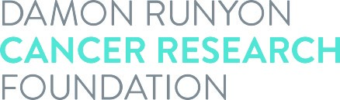

Damon Runyon Fellowship
Dependent Child Allowance Request

The Foundation provides a Dependent Child Allowance of $1,000 per child per year. (There is no allowance for a spouse.) Eligible Fellows must provide a copy of the birth or adoption certificate for each child. Please use one form per child.

Fellow’s Name:

Child’s Name:

Date of Birth:

Please email this form along with a copy of the birth/adoption certificate(s) to Sara Jorde, Programs Assistant, at: sara.jorde@damonrunyon.org

