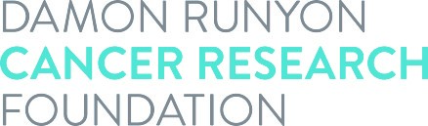

Damon Runyon Physician-Scientist Training Award
Dependent Child Allowance Request

The Foundation provides a Dependent Child Allowance of $1,000 per child per year. (There is no allowance for a spouse.) Eligible Physician-Scientists must provide a copy of the birth or adoption certificate for each child. Please use one form per child.

Scientist’s Name:

Child’s Name:

Date of Birth:

Please email this form along with a copy of the birth/adoption certificate(s) to Kyra Richardson, Programs Assistant, at: kyra.richardson@damonrunyon.org.

