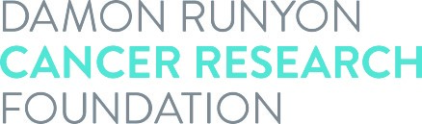

Acceptance of Award

I realize that the Damon Runyon-Rachleff Innovation Award is given to a limited number of individuals and accept this award with a good-faith intention of completing the full two-year term. It is understood by all parties that this award in no way constitutes an employer-employee relationship between the Damon Runyon Cancer Research Foundation and the recipient. I consent to the use of my name, photograph and description of discoveries related to this award as well as subsequent scientific achievements in connection with the Foundation’s solicitations and publicity of its activities. All the following parties agree to abide by the terms set forth in the Award Statement.

Damon Runyon Award recipient's signature: __________________________ Date: ___________

Print Award recipient's name:

Institutional signature: _____________________________________________ Date: ___________

Print Institutional Signee’s name: Title:

Awardee’s ORCID iD Number:

