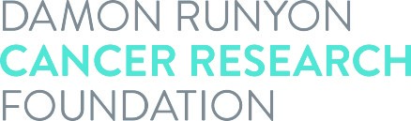

Acceptance of Award

I realize that the Damon Runyon Postdoctoral Fellowship Award is given to a limited number of individuals and accept this award with a good-faith intention of completing the full four-year term. It is understood by all parties that this award in no way constitutes an employer-employee relationship between the Damon Runyon Cancer Research Foundation and the recipient. I hereby certify that upon acceptance of the Fellowship, I will accept no other salaried awards, fellowships, or grants from other sources for the duration of this award. I will identify myself as a Damon Runyon Fellow and consent to the use of my name, photograph and description of discoveries related to this award as well as subsequent discoveries in connection with Foundation's solicitations and publicity of its activities. All the following parties agree to abide by the terms set forth in the Award Statement.

Damon Runyon Award recipient's signature:____________________________ Date: ___________________

Print Awardee’s name:

Sponsor's signature:________________________________________________ Date: ___________________

Co-Sponsor’s signature (if applicable):____________________________________ Date: ___________________

Institutional signature:_____________________________________________ Date: ___________________

Print Institutional Signee’s name: Title:

Specific types of cancer to which project relates:

Relevance of project to cancer (in layman's terms):

