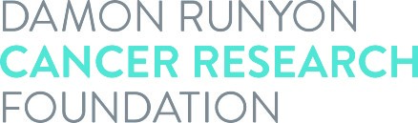

Acceptance of
Dale F. Frey Award for Breakthrough Scientists

It is understood by all parties that this award in no way constitutes an employer-employee relationship between the Damon Runyon Cancer Research Foundation and the recipient. I consent to the use of my name, photograph and description of discoveries related to this award as well as subsequent scientific achievements in connection with the Foundation’s solicitations and publicity of its activities. All the following parties agree to abide by the terms set forth in the Award Statement.

Award recipient's signature:_______________________________ Date:__________

Institutional signature:___________________________________________ Date:__________

Print Institutional Signee’s name: Title:

Awardee’s ORCID iD Number:

