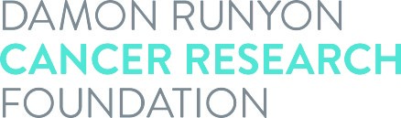

Acceptance of Award

I realize that the Damon Runyon Physician-Scientist Training Award is given to a limited number of individuals and accept this award with a good-faith intention of completing the full four-year term. It is understood by all parties that this award in no way constitutes an employer-employee relationship between the Damon Runyon Cancer Research Foundation and the recipient. I will identify myself as a Damon Runyon Physician-Scientist and consent to the use of my name, photograph and description of discoveries related to this award as well as subsequent scientific achievements in connection with the Foundation’s solicitations and publicity of its activities. All the following parties agree to abide by the terms set forth in the Award Statement.

Damon Runyon Award recipient's signature: __________________________ Date: ___________

Print Award recipient's name:

Mentor's signature: ________________________________________________ Date: ___________

Co-Mentor’s signature (if applicable): ____________________________________ Date: ___________

Institutional signature: _____________________________________________ Date: ___________

Print Institutional Signee’s name: Title:

Awardee’s ORCID iD Number:

Specific types of cancer to which project relates:

Relevance of project to cancer (in layman's terms):

